1. It is said that failure to meet the interoperability requirements can negatively affect

the correctness level of the software system, and even can cause nonconformance

with correctness requirements.

a) Elaborate on the above statement and explain the mentioned interconnections

between factors.

b) Provide an example of a situation where such effects are to be expected.

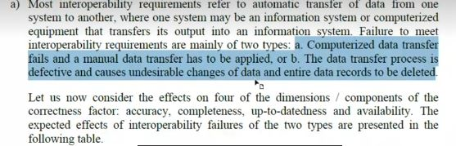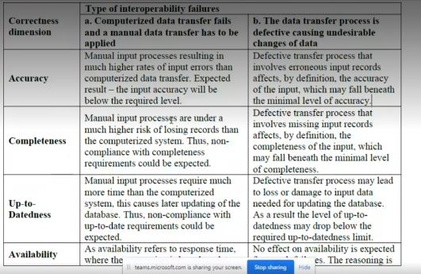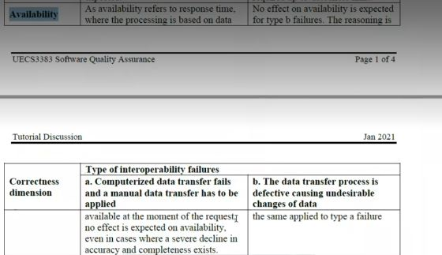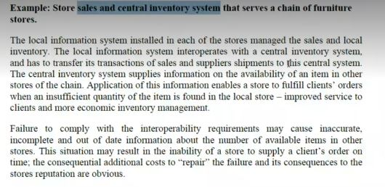

2. Development process mapping is one of the most important elements of the

development plan.

a) List the possible phases of the development process.

b) List possible inputs and outputs for each of the phases suggested in (a).

c) What components of each activity, as associated with each project phase, should

be described in the development plan?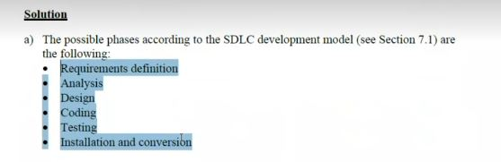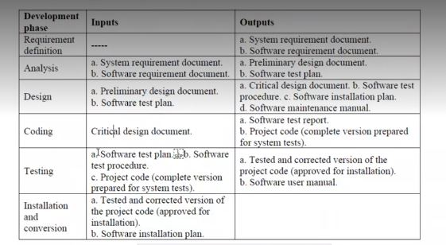

3. “As long as the proposal was properly prepared and approved, following an adequate

contract review, there is no justification for redoing all this work. Its resource

estimates and schedule can serve as the project’s plan....” You often hear claims like

this one.

a) Do you agree with this claim? If not – list your arguments against it.

b) Suggest situations where it is clear that the proposal and its materials can serve as

development and quality plans.

c) Suggest situations where it is clear that the proposal and its materials cannot serve

as development and quality plans.

